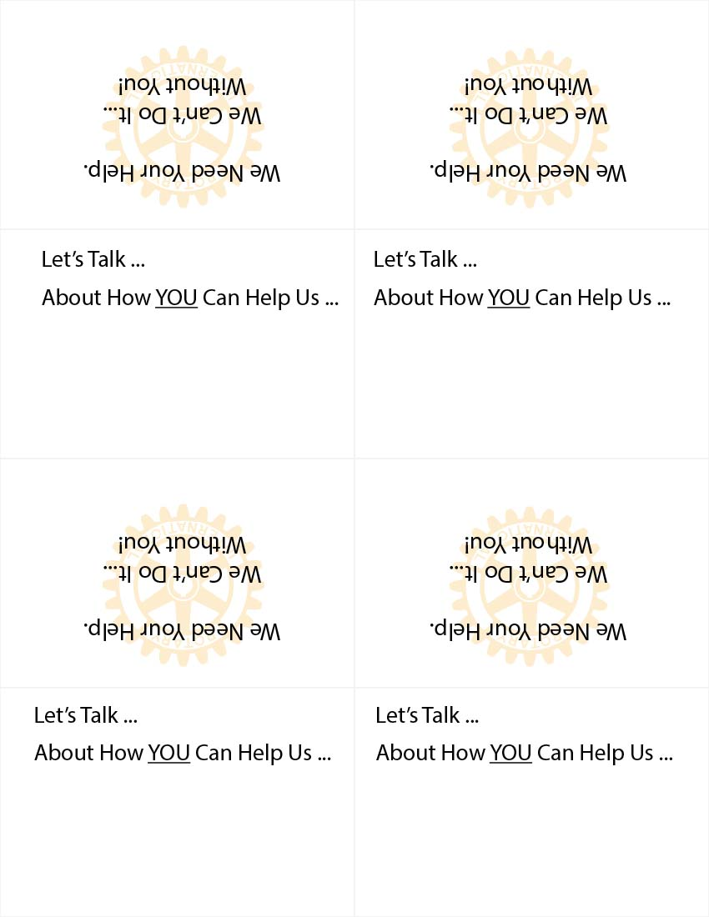

**Facebook.com/DawsonCountyRotary**

**The Rotary Club of Dawson County**

**Facebook.com/DawsonCountyRotary**

**The Rotary Club of Dawson County**

**The Rotary Club of Dawson County**

**Facebook.com/DawsonCountyRotary**

**Facebook.com/DawsonCountyRotary**

**The Rotary Club of Dawson County**